LogiMAT 2024
item showcases new intralogistics solutions

Intralogistics is all about moving materials quickly, which is where the new solutions from item come in. At LogiMAT 2024, the pioneer in building kit systems for industrial applications is exhibiting an ingenious innovation for moving materials safely using driverless transport systems, along with its new Suspended Conveyor System and the highly versatile Conveyor Belt System.

Offering a whole new concept in flexibility, the item Building Kit System paves the way for application-specific solutions for a variety of intralogistics challenges. Driverless transport systems (DTSs, such as AGVs and AMRs) are one potential application. At LogiMAT in Stuttgart, item is presenting an innovative solution for DTSs that consists of a mobile base frame and a selection of superstructures. The base frames are compatible with the systems of well-known DTS manufacturers, and a standard interface ensures a variety of superstructures can be connected to them. From pallets and mesh boxes to custom rack solutions and complete assembly superstructures – all kinds of options are available to users for adapting ideally to the relevant transport task.

Smart material supply and an efficient flow of goods
The new item Suspended Conveyor System is a simple, cost-effective and flexible solution for supplying materials. Ideal for manual or semi-automated transport, the system represents an attractive alternative to small load carriers (SLCs) and is suitable for materials with an individual weight of up to 5 kilos that easily become entangled or would take up too much space in SLCs. It is easy to put together – ESD-safe Carriages are suspended from item Conveyor Rail Profiles. Measuring up to 6 metres in length, the individual profiles can be flexibly combined. They are attached at an incline of 3° to a frame made from Profile Tube System D30 to create trolleys or frames with an integrated Suspended Conveyor System. The Carriages make their way to the removal point by gravity alone. The Conveyor Belt System from item delivers maximum flexibility, too. Customers can fit a wide range of conveyor belts and drives to a base frame that can be configured to suit their specific requirements. Both standard and ESD-safe belts are available, in a variety of surface finishes and widths. Thanks to the new railing system, everything from individual and bulk goods to SLCs can be transported safely on item conveyor belts. The width and height of the railings are individually adjustable. The goods being transported are guided directly along the low-friction aluminium profile. The system is ideal for conveying, collecting together, funnelling and sorting materials, making it a further innovative development for efficient material transport.

item at LogiMAT 2024: Hall 5, Stand 5F51

Length: 2893 characters including spaces
Date: 10 January 2024

Photos: 3 (source: item)

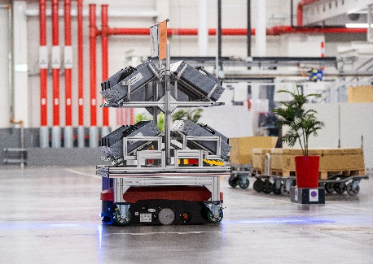
Caption 1: From pallets and mesh boxes to
custom rack solutions and complete assembly superstructures – the item innovation for DTSs makes it possible to adapt ideally to the relevant transport task in intralogistics applications.

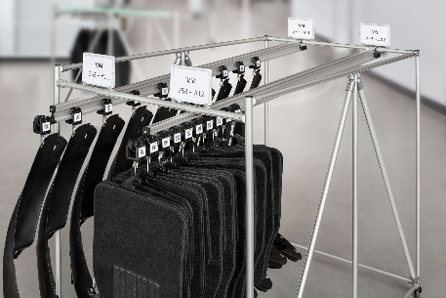
Caption 2: The new item Suspended Conveyor System is a simple, cost-effective and flexible solution for supplying materials.

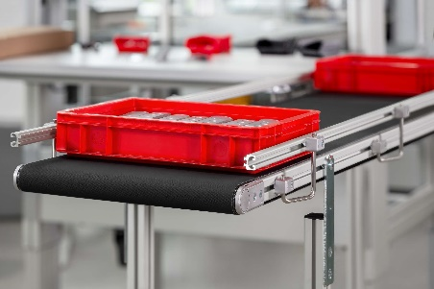
Caption 3: Thanks to the new railing system, everything from individual and bulk goods to small load carriers can be transported safely on item conveyor belts. The width and height of the railings are individually adjustable.

About item
item Industrietechnik GmbH is the pioneer in building kit systems for industrial applications and a partner of the manufacturing industry across the entire globe. Today, the item product portfolio comprises more than 4500 high-quality components designed for use in machine bases, work benches, automation solutions and lean production applications. The company has received a string of awards for products with ground-breaking industrial design and end-to-end ergonomics.

item is spearheading digital engineering by driving forward the digitalisation of processes with software tools developed in-house. The item Academy offers training at various levels, with on-demand training and online courses available in multiple languages.

Headquartered in Solingen, Germany, item has subsidiaries in various countries. Some 900 employees worldwide harness their know-how and passion to develop innovative solutions and services. Eleven sites make sure the company is always close to customers in Germany, with a global logistics chain ensuring swift delivery times for all components.

Company contact
Katja Regelin • item Industrietechnik GmbH
Friedenstrasse 107 - 109 • 42699 Solingen • Germany
Tel.: +49 212 65 80 5427
Email: k.regelin@item24.com • Internet: www.item24.com

Press contact
Jan Leins • additiv
A brand of additiv pr GmbH & Co. KG
B2B communications for logistics, robotics, industry and IT
Herzog-Adolf-Strasse 3 • 56410 Montabaur • Germany
Tel.: +49 26 02-95 09 91 6 • Fax: +49 26 02-95 09 91 7
Email: jl@additiv.de • Internet: www.additiv.de

