item presents this autumn’s new products
Railing system – safe guidance for individual and bulk goods

Whether goods are large or small, wide or narrow – the item railing system 8 D8 guides all kinds of materials, accommodating loads of up to 250 N, on conveyor belts designed for this purpose. The system, which can easily be adapted to suit different requirements, safely guides conveyed loads to where they are needed. When extra-gentle guidance is needed, additional slide strips can simply be clipped onto the low-friction aluminium profiles.

The new item railing system 8 D8 provides the necessary design freedom to safely guide all kinds of conveyed loads in any situation. It can be used, for example, when the materials being conveyed are wider than the conveyor belt itself. This system, which is among the new item products launched this autumn, features many benefits – adjustable height and width, quick and easy installation, and an attractive, efficient design.

Guiding conveyed loads safely and flexibly
The railing system 8 D8 consists of three new components. Railing Holder 8 D8 is screwed into the Line 8 groove at the side of the conveyor belt and provides the connection to the railing profile. Brackets in two variants (J 80 D8 / J 130 D8) mean the height and width of the system can be optimally adjusted to suit the goods being conveyed. Thanks to the wide pivot range, users can adjust the position of the railing quickly and intuitively. The brackets can easily be aligned so they are positioned either inside or outside the conveyor line, meaning that railing system 8 D8 can be used to safely guide not only small load carriers (SLCs) with standard dimensions, but also other containers and bulk goods. The sturdy Profile 8 24x20 D30 serves as the railing. It features a specially optimised contour, so you can guide transported goods directly along its low-friction aluminium surface or clip on various plastic slide strips, which are available in a variety of colours, for even gentler guidance. For example, Slide Strip 5 ESD and Slide Strip D30 fit the optimised profile.

Maximum flexibility for every situation
The railing system is based on a small number of basic components that can be combined in a variety of ways. It is therefore perfectly integrated into the item Building Kit System and can also be used with other profiles by changing the T-slot nut. However, conventional SLCs are not the only loads that can be safely guided along the rail – the system is also ideal for collecting together or funnelling individual objects that could easily slip off the conveyor belt if there was no railing. The new railing system is a perfect solution for sorting transported goods, too.

Further information is available in our e-paper: item new products – item (item24.com)

Length: 2547 characters including spaces
Date: 12 December 2023

Photos:
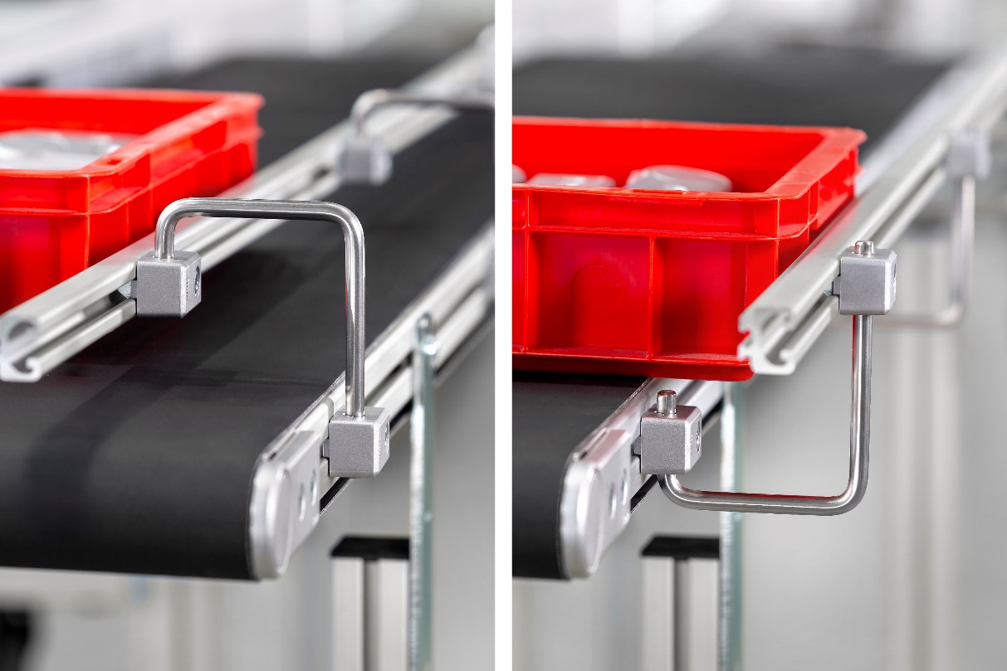

Bildunterschrift: The new item railing system 8 D8 provides the necessary design freedom to safely guide all kinds of conveyed loads in any situation. It can be used, for example, when the materials being conveyed are wider than the conveyor belt itself.

Photos: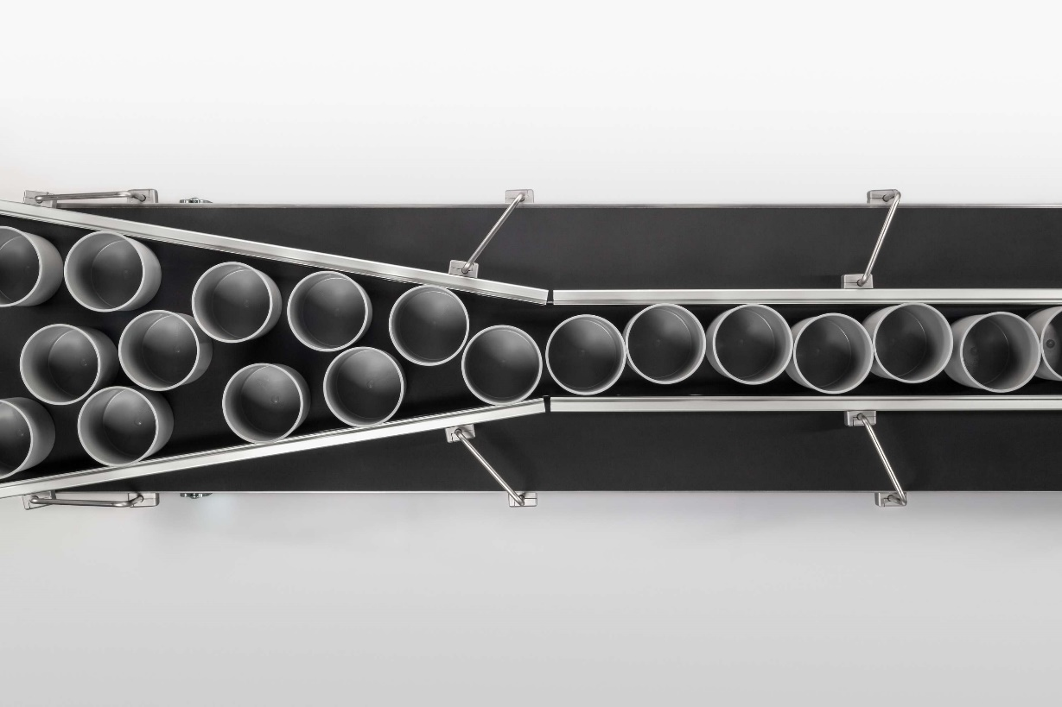

Bildunterschrift: The system is ideal for collecting together or funnelling individual objects. The new railing system is a perfect solution for sorting transported goods, too.

About item
item Industrietechnik GmbH is the pioneer in building kit systems for industrial applications and a partner of the manufacturing industry across the entire globe. Today, the item product portfolio comprises more than 4500 high-quality components designed for use in machine bases, work benches, automation solutions and lean production applications. The company has received a string of awards for products with ground-breaking industrial design and end-to-end ergonomics.

item is spearheading digital engineering by driving forward the digitalisation of processes with software tools developed in-house. The item Academy offers training at various levels, with on-demand training and online courses available in multiple languages.

Headquartered in Solingen, Germany, item has subsidiaries in various countries. Some 900 employees worldwide harness their know-how and passion to develop innovative solutions and services. Eleven sites make sure the company is always close to customers in Germany, with a global logistics chain ensuring swift delivery times for all components.

Company contact
Katja Regelin • item Industrietechnik GmbH
Friedenstrasse 107 - 109 • 42699 Solingen • Germany
Tel.: +49 212 65 80 5427
Email: k.regelin@item24.com • Internet: www.item24.com

Press contact
Jan Leins • additiv
A brand of additiv pr GmbH & Co. KG
B2B communications for logistics, robotics, industry and IT
Herzog-Adolf-Strasse 3 • 56410 Montabaur • Germany
Tel.: +49 26 02-95 09 91 6 • Fax: +49 26 02-95 09 91 7
Email: jl@additiv.de • Internet: www.additiv.de

