Collaborative robots in industrial assembly processes
How cobots can be successfully implemented

Collaborative robots can be used in a variety of ways to assist humans and ease their workload. One example of a successful cobot project for industrial assembly processes is “Cobra20”. This collaborative robot in the warehouse and production centre run by item takes on the task of fitting a roller.

Collaborative robots perform repetitive tasks with precision and can take on monotonous, strenuous and even dangerous production work. However, the introduction of cobots is not always plain sailing and scepticism about human-cobot systems persists. Yet things don’t need to be that way, as item is proving at its state-of-the-art Piepersberg manufacturing and distribution centre in Solingen. By involving staff at an early stage, the company achieved a high level of acceptance for cobot technology among employees, which helped make the project a success.

Identifying an appropriate task
To ensure it could use the cobot to optimise processes in line with the lean production philosophy, item focused on the manual tasks on the assembly line. The plan was to partially automate these tasks – and to do so with as little outlay as possible. A special team was set up and examined all machining, assembly and final production processes. The team looked at the entire process chain, individual products and the systems used. In the end, they decided to use the cobot to install a particular roller, thus assigning it a task that is very tiring and monotonous for staff. The robot picks up the individual components, places them in the assembly device for automated assembly and sorts the finished product into a workpiece carrier. Staff now only fill up the magazines, replenish parts and supervise the process. Several operations have been streamlined and staff workload has been reduced by 90 percent.

Involving employees at an early stage
Przemyslaw Krzysztyniak, project and innovation manager at item, believes it is crucial to involve staff from all departments early on. Requests and ideas were taken into account, outcomes were openly documented and all those involved were kept informed on an ongoing basis. This approach helped item ensure the new technology was accepted. The staff are still an important part of the assembly process. They use the cobot like a tool and set their own pace. The robot is now seen as part of the team and was even given the name “Cobra20”, with reference to its snake-like movement and year of commissioning.

In addition to human factors, safety aspects must be considered when implementing robots. These include Machinery Directive 2006/42/EC and various standards and technical specifications. Human-machine collaboration can achieve significant cost efficiency and can even make “batch size one” production commercially viable. To be able to use Cobra20 efficiently in the future, item is already planning ahead. For example, the cobot will soon be used for screw-fixing applications and thus manufacture components from three different product groups. One last important consideration for the success of a project like this is that collaboration with reliable partners is crucial to ensure suitable components for robot peripherals are available.

Length: 3,648 characters including spaces
Date: 4 April 2022

Photos: 1 (source: item)

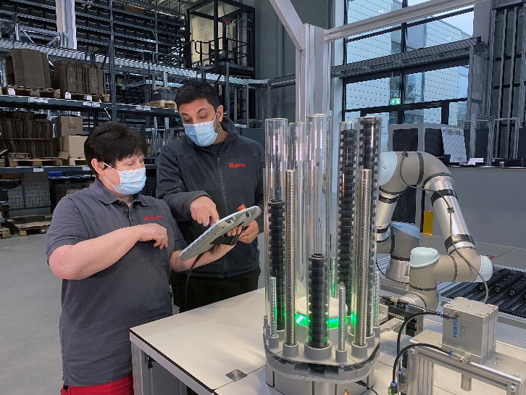
Caption 1: Cobot “Cobra20” is responsible for fitting a roller in the storage and production centre run by item. By involving staff at an early stage, the company achieved a high level of acceptance for cobot technology among employees, which helped make the project a success.

About item
item Industrietechnik GmbH is the pioneer in building kit systems for industrial applications and a partner of the manufacturing industry across the entire globe. Today, the item product portfolio comprises more than 4,000 high-quality components designed for use in machine bases, work benches, automation solutions and lean production applications. The company has received a string of awards for products with ground-breaking industrial design and end-to-end ergonomics.

item is spearheading digital engineering by driving forward the digitalisation of processes with software tools developed in-house. The item Academy offers training at various levels, with on-demand training and online courses available in multiple languages.

Headquartered in Solingen, Germany, item has subsidiaries in various countries. Some 900 employees worldwide harness their know-how and passion to develop innovative solutions and services. Twelve sites make sure the company is always close to customers in Germany, with a global logistics chain ensuring swift delivery times for all components.

Company contact
Nicole Hezinger • item Industrietechnik GmbH
Friedenstrasse 107 - 109 • 42699 Solingen • Germany
Tel.: +49 212 65 80 5188 • Fax: +49 212 65 80 310
Email: n.hezinger@item24.com • Internet: www.item24.com

Press contact
Jan Leins • additiv pr GmbH & Co. KG
Press work for logistics, steel, industrial goods and IT
Herzog-Adolf-Strasse 3 • 56410 Montabaur • Germany
Tel.: (+49) 26 02-95 09 91 6 • Fax: (+49) 26 02-95 09 91 7
Email: jl@additiv-pr.de • Internet: www.additiv-pr.de/maschinenbau

