Maximum flexibility thanks to a modular system
Designing customised clean
production environments

Numerous sectors need to use cleanrooms when manufacturing their products, and there are plenty of solutions on the market for fitting them out. However, standard systems are often of limited use when it comes to finding the optimum solution for the various requirements associated with cleanroom technology. What organisations need instead is a range of suitable components that can be combined to create customised working and production areas.

Whether in the pharmaceutical and medical sector, semiconductor production, aerospace engineering, optics or research – cleanrooms are essential wherever it is vital to exclude any chance of products being contaminated with even the smallest particles. The limit values for the various classes of cleanroom are set out in the DIN EN ISO 14644-1 standard, which defines the number of particles of a specific size permissible per cubic metre. “Quality standards are rising all the time,” says Kevin Haas, item Product Manager for clean production. “We are seeing a growing market interest in cleanroom-compatible products.”

Work benches for clean production
As the pioneer in building kit systems for industrial applications, item offers numerous systems that are suitable for installation in cleanrooms. One example is the Work Bench System, which is not only ergonomic and ESD safe, but with just a few modifications can also be used to build work benches for clean production. To make a construction suitable for use in cleanrooms, the grooves of the aluminium profiles in the structure are sealed with appropriate covers and cables are routed inside the profiles, for example. This results in smooth surfaces that are particularly easy to clean. The portfolio is rounded off by an HPL (high pressure laminate) table top adapted to the relevant requirements and a storage surface in the handling area finished with a panel of Perforated Sheet. To ensure there is nothing above the working surface that can cause problems, lights are mounted at the sides. The result is a work bench on which very few particles of dust or other material can accumulate. A height-adjustable table column set certified to ISO class 5 allows for optimum ergonomic adjustment. By using an ESD table top and numerous other components, it is also possible to create comprehensive ESD protection – an additional bonus when it comes to protecting sensitive products from electrostatic discharge.

Supplying filtered cleanroom air to defined areas
item has expanded its portfolio to include specialist components that can be used to build customised laminar flow boxes. A model solution can be ordered directly from the Online Shop in the form of an example application. This example application incorporates suitable lighting, a 230 V connection and a Filter Fan Unit (FFU) that combines a filter and centrifugal fan and generates a clean, low-turbulence, laminar air flow over the working surface. The FFU uses Pre-Filter M5 and HEPA Filter H14 to remove 99.995 percent of all particles from the ambient air. Its filtration efficiency has been tested to DIN EN 1822. A half-height, fold-away panel at the front ensures that the air above the table top does not get swirled around. Staff can reach under the panel to carry out the necessary work. The base, consisting of a table top and aluminium profiles with sealed grooves, can also be supplied in a height-adjustable version. The laminar flow box is available without a base frame, too. This example application meets the specifications of ISO class 5 to DIN EN ISO 14644-1.

Targeted airflow routing for smooth operations
Process enclosures from item are ideal for production facilities that have to meet the highest requirements in terms of cleanliness. Line X and XMS profiles can be used to create cleanroom-compatible machine cabins with air recirculation. This example application that can be ordered directly is certified and meets the specifications of class 2 to DIN EN ISO 14644-1. The upper part of the service section incorporates two integrated FFUs. Air is filtered and then fed into the process room. The air flows into the lower part through a panel of Perforated Sheet. From there, the air is recirculated to the upper part via a double wall. One advantage of recirculating the air in this way is that it extends the service life of the filter. For example, if the machine enclosure is in a heavily contaminated environment, the filter does not degrade so quickly, as the air is only drawn in from its surroundings at the start, after which the circulated air has already been cleaned. As a result, there is no reason for frequent process interruptions to change the filter. Other advantages include the cable conduits integrated into the supporting profiles that enable safe, straightforward cable routing. Cover profiles and the new Fixing System make the aesthetically pleasing constructions ideally suited for use in production facilities with the strictest cleanroom requirements.

Customised design thanks to modular components
The item Building Kit System gives users the opportunity to design a cleanroom-compatible work bench system to suit their own specific needs. It is easy to make modifications, because the modular components are coordinated with each other and can be combined. “Our components can be used to create solutions for cleanrooms in various dimensions,” says Haas. “They can also be reconfigured at any time, and additional tools, holder systems, special magnifying glasses and other materials can be incorporated. We are not selling an off-the-peg system, we are offering maximum flexibility.” The FFU is not the only piece of cleanroom equipment item has added to its Building Kit System. A special Fixing System for creating flush surfaces – walls and ceilings – is also new. Panels of 4-5 mm thickness, 36 mm-thick laminated safety glass and thin, 3-mm Perforated Sheet can be securely fastened using this, creating a range of wall and ceiling structures with easy-to-clean joins. Perforated Sheet can also be fixed horizontally, serving equally well as a working surface or storage shelf. Thanks to its high holding force, the Fixing System can also be used to hold in place the FFU.

Summary: item has added new components to its Building Kit System that give users the option to design their own custom cleanroom solutions. The end results are cleanroom-compatible, ESD-safe and ergonomic working and production areas. Thanks to comprehensive assembly guides, technical information, numerous example applications and skilled consultation, the company also provides wide-ranging design support.

Length: 7,014 characters including spaces
Date: 4 October 2023

Images: 2 (source: item)

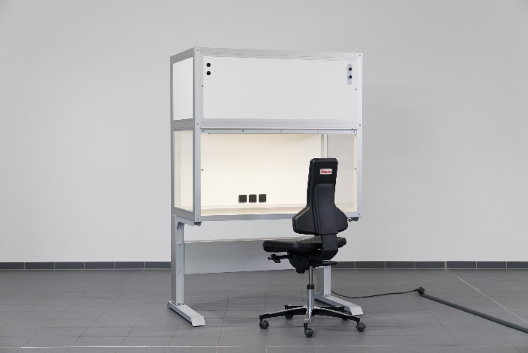
Caption 1: Specialist components from the item Building Kit System can be used to create customised laminar flow boxes. This example application achieves the specifications of ISO class 5 to DIN EN ISO 14644-1 and can be ordered directly via the Online Shop.

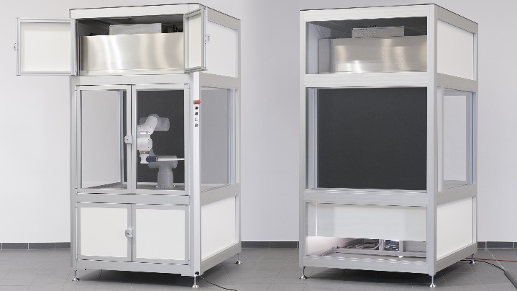
Caption 2: This example application for a cleanroom-compatible machine cabin is fitted with two FFUs and can be adapted to different requirements and extended as required. Air is recirculated via the rear double wall.

Company contact
Nicole Hezinger • item Industrietechnik GmbH
Friedenstrasse 107 - 109 • 42699 Solingen • Germany
Tel.: +49 212 65 80 5188 • Fax: +49 212 65 80 310
Email: n.hezinger@item24.com • Internet: www.item24.com

Press contact
Jan Leins • additiv pr GmbH & Co. KG
Press work for logistics, steel, industrial goods and IT
Herzog-Adolf-Strasse 3 • 56410 Montabaur • Germany
Tel.: +49 26 02-95 09 91 6 • Fax: +49 26 02-95 09 91 7
Email: jl@additiv-pr.de • Internet: www.additiv-pr.de/maschinenbau

