Methods and strategies for lean production
Using lean production to significantly improve processes

Combining short delivery times with efficient, flexible manufacturing, lean production has been regarded as standard practice for cutting-edge manufacturing ever since the 2000s. Numerous lean methods are available to help companies achieve their lean production goals.

Lean production leads to growth, because the principle itself and the associated improvement in a company’s processes result in shorter throughput times in production. Orders and productivity increase, too. Contrary to the frequently expressed assumption, rolling out lean production does not mean job cuts. In fact, more staff are required due to the increased volume of orders. Lean production also creates a corporate culture based on trust and transparency that actively involves employees in processes. Entirely in keeping with DIN EN ISO 9001, direct involvement of the relevant people is necessary to achieve higher quality and improve workflows.

Many types of waste exist
In lean production, a change for the better is referred to as “Kaizen”. The objective is a continuous improvement process, with every part of the company being regarded as capable of improvement. A culture of open feedback and a positive attitude towards mistakes are needed to highlight potential for improvement and successfully implement corresponding measures. Staff are at the heart of the lean philosophy. A great deal of responsibility for the processes is transferred to them, and they have extensive decision-making authority in their particular area. Instead of standards for processes simply being set out in advance, staff determine these for themselves. After all, they are best placed to evaluate why, for instance, throughput times in production are longer than expected, and where and how improvements should be made. Besides waste (Muda), it is also important to avoid imbalance (Mura) and overloading (Muri). Mura is generally to be regarded as the source of waste. When rolling out a lean strategy, it is therefore advisable to start by eliminating Mura and to treat all three Ms equally. In lean production, seven types of Muda are referred to – unnecessary movement of materials (transport), high stock levels (inventory), unnecessary movements (motion), avoidable waiting times (waiting), surplus production (overproduction), overly complex processes (overengineering) and rejects/reworking (defects).

The 5S method, value-stream mapping and value-stream design
The 5S method can help improve a company’s processes by eliminating waste. This involves removing everything from the workplace that is not directly needed there (Seiri). Using an ergonomic platform makes it possible to organise materials on a systematic basis (Seiton). The workplace must also be cleaned thoroughly (Seiso), and disorder should be avoided (Seiketsu). Last but not least, staff must follow measures in a disciplined manner and must take into account all the aspects referred to (Shitsuke). These five Ss make it possible to rapidly analyse processes and answer the following question: Is a process running in accordance with the standards? Employees are ideally split into small teams and assisted by a manager. Once the standards have been determined according to the 5S method, the value stream is mapped. This means identifying the actual situation and making the value stream visible. It involves observing the individual process steps required to manufacture a product, measuring the time they take and visualising them. First of all, products with similar process steps must be grouped and an associated matrix created. The actual situation can then be depicted in a flow diagram. Starting from the customer, the production steps are visualised based on the planning undertaken. The value-stream diagram shows potential for improving aspects such as throughput time, stock levels and the synchronisation of work steps. Once the actual situation has been ascertained, the target standard is then defined by jointly deciding what form the improved process chains should take. Once again, a value-stream diagram can help visualise the desired target standard. Processes are then gradually improved by eliminating the operations that do not add value, along with excessive waiting times. These changes should be completed within three to six months. The resulting direct benefits for the customer include shorter delivery times, but also changes within the company – from the ability to react faster and enhanced flexibility to optimised warehousing. This goes hand in hand with cutting costs. As a rule of thumb, a 90 percent shorter throughput time is equivalent to a 30 percent reduction in costs.

PDCA cycle delivers continuous improvement
The PDCA cycle can help improve processes in lean management. PDCA stands for “Plan”, “Do”, “Check” and “Act”. The starting point is to focus on one undertaking and analyse this based on facts, figures and data. Next, a plan is developed to initiate the continuous improvement process. It is important to concentrate on a particular measure to achieve the goal. All this takes place in close collaboration with staff. This “Plan” stage is followed by the “Do” stage, which should begin with a measure being implemented in a practical experiment. It helps to start small. The subsequent “Check” stage shows which measures work and which strategies may need to be adapted. The final stage is to “Act”. Ideally, this should be documented and verified. If implementation has produced successful results, the measure can be made standard. Otherwise, the PDCA cycle starts over.

The lean methods Heijunka and SMED
Heijunka essentially means “levelling and smoothing” and is a method for planning and controlling production. Overloading and the associated stress should be prevented, as should potential errors and underutilisation. The aim is to achieve a production flow that is virtually constant. For this purpose, the production volume is brought into proportion with the production time. Instead of planning production for a whole month, for example, it can be beneficial to plan on a weekly or even a daily basis. This makes it easier to cope with fluctuations in demand, because production is adjusted on a flexible basis. This kind of planning also necessitates shorter setup times, though, as several changeovers are required. It results in faster, more flexible deliveries and reduced warehousing. The error rate is also much lower. A further prerequisite for implementing Heijunka is efficient material supply. Work benches must be designed appropriately – ergonomically optimised, with a space-saving arrangement of tools and materials. Switching production to smaller batch sizes goes hand in hand with shorter setup times. This is where the Single-Minute Exchange of Die (SMED) method comes in. The objective is to limit the setup time to a maximum of 10 minutes, although the ideal setup time would be 0 minutes. This is only possible if internal setup processes are turned into external ones. Machines then no longer need to be stopped while operating and production processes no longer need to be interrupted. Instead, the changeover takes place outside the process. The predefined goal can be achieved thanks to technical optimisations and factory equipment designed specifically for lean production. More frequent but shorter setup processes mean more products can be manufactured in the same amount of time.

Using the pull principle to reduce delivery times
Companies can use the SMED method to achieve pull production. Instead of producing on the basis of sales forecasts and keeping high levels of stock available to cover any peaks in demand, production is based on the demand that actually exists. This avoids overproduction. The problem with push production is that storage areas, for example, get overfull if the expected demand fails to materialise or does so later than predicted. Capacity and capital are tied up without products generating direct revenue, which results in further types of waste. The throughput time increases, too, because the material flow is constantly interrupted when products are being placed into and removed from storage, including interim storage. The push principle is thus incompatible with lean principles. With the pull strategy, on the other hand, production is designed for short setup times. This also paves the way for small batch sizes. An uninterrupted material flow is created, overproduction is avoided and the storage area can be reduced. Shorter delivery times are a further advantage. Companies thus benefit in many different ways from this efficient and flexible manufacturing.

When rolling out lean production, it is important always to focus on the entire process chain, because merely optimising one individual process does not result in a resounding success. The changes will only pay off if companies are willing to systematically implement measures and firmly establish the lean philosophy across the board. Efficient processes not only cut costs, but also have a positive impact on the satisfaction of staff and customers. Appropriate measures can significantly cut delivery times and it is possible to avoid peak workloads.

Length: 10,038 characters including spaces
Date: 6 December 2022

Images: 4

Caption 1: Lean production aims to achieve continuous improvement. Amongst other things, unnecessary movements and material flows should be avoided.

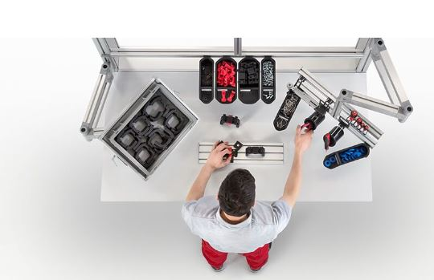
Caption 2: In line with the 5S method, everything at the workplace that is not directly needed there should be removed (Seiri). Ergonomically optimised work bench systems from item offer countless possibilities for doing just that.
Caption 3: To analyse the actual situation, production steps are visualised based on planning undertaken. The value-stream diagram shows potential for improving aspects such as throughput time, stock levels and the synchronisation of work steps.
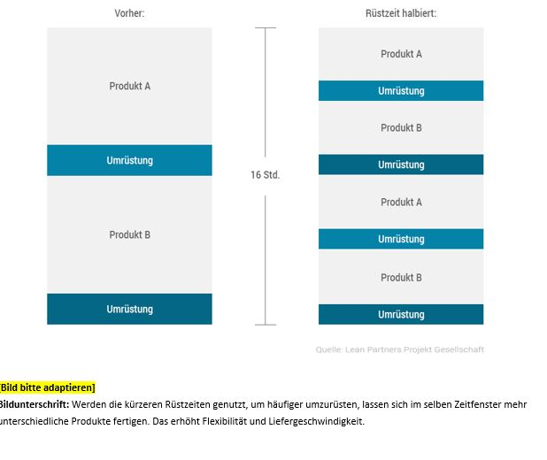
Caption 4: Companies can use the SMED method to achieve pull production and shorter setup times.

About item
item Industrietechnik GmbH is the pioneer in building kit systems for industrial applications and a partner of the manufacturing industry across the entire globe. Today, the item product portfolio comprises more than 4000 high-quality components designed for use in machine bases, work benches, automation solutions and lean production applications. The company has received a string of awards for products with ground-breaking industrial design and end-to-end ergonomics.

item is spearheading digital engineering by driving forward the digitalisation of processes with software tools developed in-house. The item Academy offers training at various levels, with on-demand training and online courses available in multiple languages.

Headquartered in Solingen, Germany, item has subsidiaries in various countries. Some 900 employees worldwide harness their know-how and passion to develop innovative solutions and services. Twelve sites make sure the company is always close to customers in Germany, with a global logistics chain ensuring swift delivery times for all components.

Company contact
Nicole Hezinger • item Industrietechnik GmbH
Friedenstrasse 107 - 109 • 42699 Solingen • Germany
Tel.: +49 212 65 80 5188 • Fax: +49 212 65 80 310
Email: n.hezinger@item24.com • Internet: www.item24.com

Press contact
Jan Leins • additiv
A brand of additiv pr GmbH & Co. KG
B2B communications for logistics, robotics, industry and IT
Herzog-Adolf-Strasse 3 • 56410 Montabaur • Germany
Tel.: +49 26 02-95 09 91 6 • Fax: +49 26 02-95 09 91 7
Email: jl@additiv.de • Internet: www.additiv.de

